There are several ways to arrive to Montpellier.

1. By airway to Montpellier.
You’ll land at Montpellier – Méditerranée (MPL).

a.
To go to center of town, you may take the bus shuttle N°620 that will bring you to Place de l’Europe for 2€, in 25 minutes.

Schedules :
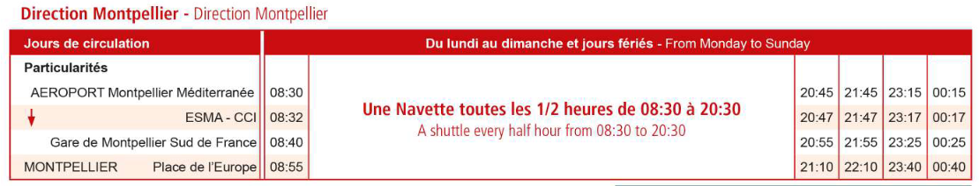
From Place de l’Europe, it’s a 20mn walk to Place de la Comédie (most center place of the city), 13min to Salle Pagezy (our venue).
You may also take the tramway, Line 1 – direction MOSSON. It’ll bring to center of town (stop COMEDIE might be central). In approx. 10 min.

Bus+Tram = 3€

Regarding to where you are going, please ask us, we’ll give you the best itinerary.

b.
You may also take a taxi. It’ll cost you around 35€.

Association des Taxis Aéroport de Montpellier
Tél. : 04 30 96 60 60
(Payment by bank check, cash or credit card accepted)

2. By airway via Marseille

You’ll land at Marseille Provence.
Marseille is a 2hour drive to Montpellier.
You may take a train to get there :
Departure : Vitrolles-Marseille Provence
Destination : Montpellier St Roch
Takes about 2hours. Costs between 15 and 35€.

!! Trains in France are most of the time on time, but…. We don’t trust them that much. If you are short in time, this might not be the best way to attend Montpellier. You should count a little bit more time ahead in case of ant delay !!

To get your train tickets, it’s over here : https://www.sncf-connect.com/billet-train

If you arrive by train, you have 2 stations available : Montpellier St Roch and Montpellier Sud de France.
Montpellier St Roch is center of town (10 mn walk from our venue, 3 mins from Place de la Comédie, 5 min from Polygone Commercial Center).
Montpellier Sud de France is outside the city. Transportation may take a while.

If you have no choice and arrive at Sud de France, here’s the travel plan :
There’s a bus shuttle to Place de France, then tramway (line 1 to center of town).

It takes between 40min and 55min.

Please, once you know where you arrive and where you are going (hotel, venue, or wherever), tell us so we can help you with your travel plans if needed.

